**Lab 8 – Exercise 1**

|  |
| --- |
| **Difficulty Level: Basic** |

**Overview**

You have been provided with a HTML file that includes all the necessary markup. You are going to make use of the DOM and event handling.

**Instructions**

1. Examine exercise1.html. Open in browser. You will add event handlers to the click events of the icons to make the alert panels fade to transparent.
2. There is already a reference to external JavaScript file called exercise1.js. You will add in your code to this file. **You must not make any changes to the markup or CSS.**
3. You will have to execute your JavaScript after the page has loaded.
4. You should have a single click handler for all the close buttons.
5. When the close button is clicked, your code should fade its alert panel to transparent. You can make use of the new CSS3 transition property. For instance, in JavaScript, setting an object’s transition style property to "opacity 1s" tells the browser to transition the opacity to its **next** setting across one second of time. This means you will also need to programmatically set the opacity property as well.

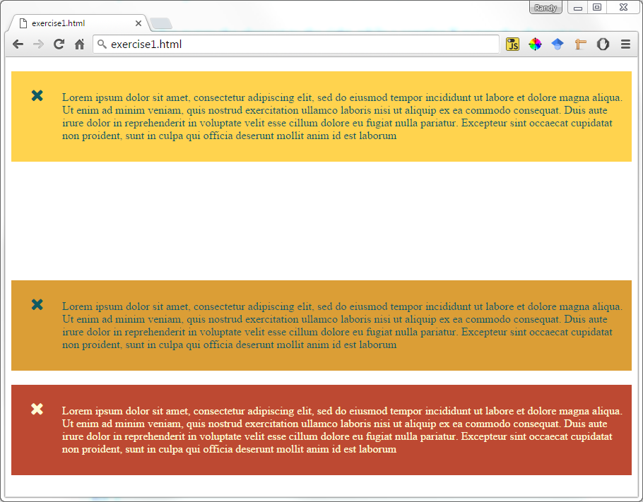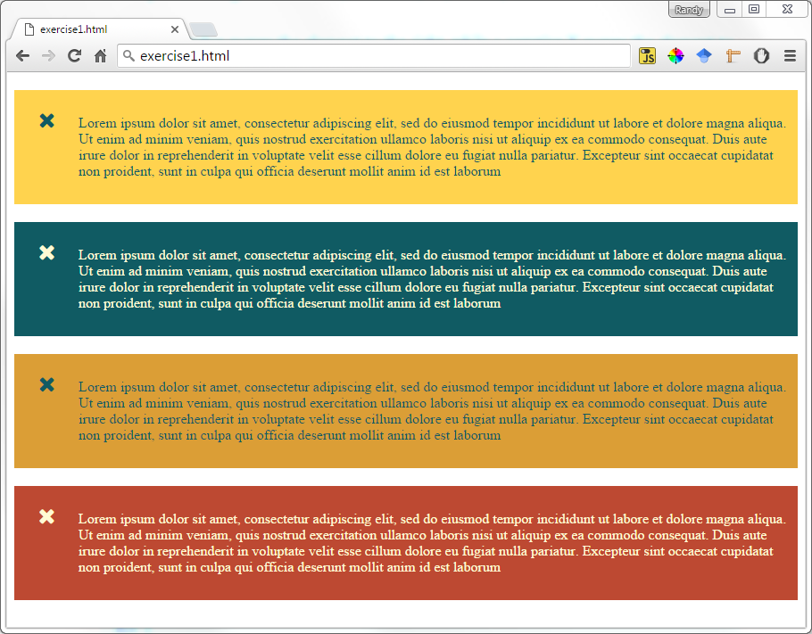

**Lab 8 – Exercise 2**

|  |
| --- |
| **Difficulty Level: Intermediate** |

**Overview**

You have been provided with a HTML file that includes all the necessary markup. You are going to make use of the DOM and event handling.

**Instructions**

1. Examine exercise2.html. Open in browser. You will add event handlers to the thumbnail images and to the larger image / figure as well.
2. There is already a reference to external JavaScript file called exercise2.js. You will add in your code to this file. **You must not make any changes to the markup or CSS.**
3. You will have to execute your JavaScript after the page has loaded.
4. You are going to add a click event handler to each of the thumbnail images. When the smaller image is clicked, your code will show the larger version of the image in the <img> element within the <figure> element. This same event handler will also set the <figcaption> text of the <figure> to the clicked thumbnail image’s title attribute**. Your event handler must use event delegation** (that is, the click event handler will be attached to the <div id="thumbnails"> element and not to the individual <img> elements).
5. 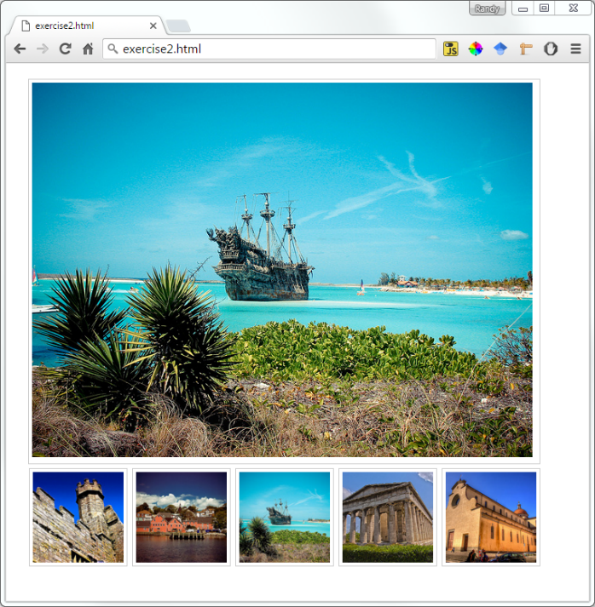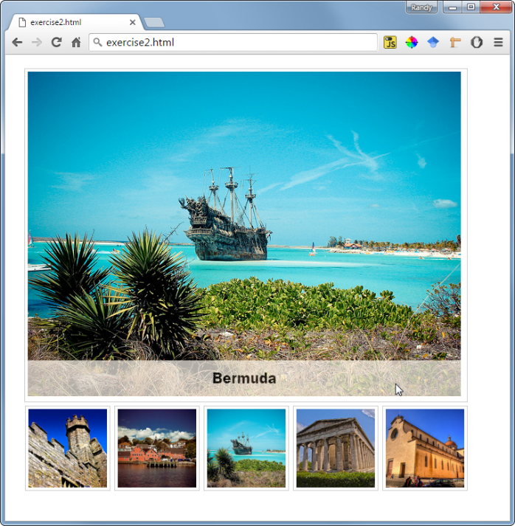You must also add event handlers to the mouse over and mouse out events of the <figure> element. When the user moves the mouse over the larger image, then you will fade the <figcaption> element to about 70% opacity (its initial CSS opacity is o% or transparent / invisible). When the user moves the mouse out of the figure, then fade the <figcaption> back to 0% opacity.